**Applied Portfolio Management**

Name

University

Course Name

Instructor Name

Date

1. **Presentation of the Strategy**

We examine the economic intuition underlying the "Quality" factor in equities markets in this section. This complex approach, as outlined by AQR and eminent financial experts, is predicated on great profitability, robust growth, and a dedication to low risk and leverage. We explore the fundamental ideas behind this strategy's allure and discuss why success is anticipated. As we begin this trip through the factor's essential components, our audience—the seasoned Chief Investment Officer—seeks a deep understanding of the factor's economic basis.

The "Quality" strategy is based on three core ideas in economics: growth, safety, and profitability. A company's profitability indicates how well it generates earnings. Promising sales and profit potential are indicated by strong growth. Safety, which includes low risk and leverage, is a sign of sound financial standing. These ideas are important to stock investors because they influence the way that investments are made. Stability is provided by low risk and leverage, but high profitability and expansion offer the possibility of rewards. The "Quality" method is a strong option for investors looking for stable and profitable equities because it uses these characteristics to choose companies that are predicted to provide consistent returns (Asness et al., 2019).

It is appealing to invest in profitable businesses for a number of reasons. First off, a strong competitive position in the market is frequently reflected in significant profits. These businesses have proven they can beat rivals, which may be the consequence of strong cost control, strong pricing, or distinctive goods or services. Second, a high profitability level denotes effective operations, meaning the business is making the most of its resources in order to turn a profit. These companies tend to provide steady profits and are better suited to withstand economic downturns, which attracts investors (Bouchaud et al., 2016).

Strong growth is a significant factor in stock selection as it offers the potential for higher returns. Companies with substantial growth prospects are well-positioned to capitalize on expanding market opportunities, innovate, and gain market share. Investors seek such companies because they anticipate that the growth will lead to capital appreciation and rising stock prices.

Leverage and low risk are two things that investors really like. Low-risk equities lessen a portfolio's exposure to financial instability and market volatility. Businesses with reduced risk profiles are thought to be solid investments that can withstand fluctuations in the economy. Low leverage, on the other hand, denotes a cautious financial strategy and lowers the possibility of financial risk. Low-leverage stocks are less vulnerable to financial shocks, which makes them a desirable option for investors who are risk averse.

Whether the "Quality" method is a safe investment option or a risky aberration is a crucial question to answer. Although this approach may seem unorthodox to some, it is based on well-established economic theories. The "Quality" method uses these ideas to build a solid investment portfolio that puts stability and consistency first, as opposed to being a high-risk endeavor. It makes sense for investors looking for steady returns because it adheres to the rules of responsible investing. The strong approach known as "quality" strategy is based on the financial pillars of growth, profitability, and safety. By adhering to these values, it establishes itself as an appealing option for investors looking for stability and adaptability in the constantly changing stock market environment.

**2. Quantile Analysis**

**Profitability Component Analysis:**

The Profitability component's predictive ability is consistently low across quantiles, according to the analysis. Profitability and the quality factor have a correlation of around 0.1288 at the 10th percentile, and about -0.0049, -0.0139, -0.0107, and -0.0098 at the 25th, 50th, 75th, and 90th percentiles, respectively. Despite being there, these correlations are somewhat near to zero, indicating that profitability's capacity to forecast the quality component is constrained.

It's interesting to note that these correlations don't dramatically alter over quantiles, suggesting that changes in profitability levels have little bearing on the predictive capacity of the data. In essence, Profitability's ability to forecast the quality factor remains consistently weak over the entire sample, and there is no evidence of its predictive power changing over time.

**Growth Component Analysis:**

Like profitability, the growth component consistently shows poor predictive potential. Growth's quantile analysis shows that the relationships with the quality component are still weak at various quantiles. Growth, for instance, has a correlation of roughly -0.0397 at the 10th percentile and -0.0010 at the 50th percentile. The relationships between the other quantiles are likewise nearly negligible. These results imply that Growth has very little predictive power over the quality factor and is not affected by variations in Growth values. Essentially, Growth's predictive value is consistently low throughout time, suggesting that it does not significantly influence the quality component.

**Safety Component Analysis:**

The analysis of the Safety component mirrors the results of Profitability and Growth. Safety, at different quantiles, exhibits consistently weak correlations with the quality factor. For instance, at the 10th percentile, Safety has a correlation of approximately -0.0526, while at the 50th percentile, it is approximately -0.0312. The correlations at the other quantiles are also negative and close to zero. This analysis reinforces the idea that Safety's predictive power remains weak and relatively unchanging over time. Similar to Profitability and Growth, Safety's contribution to forecasting the quality factor appears to be limited.

**Overall Analysis:** In summary, the detailed quantitative analysis of the three components—Profitability, Growth, and Safety—indicates that their predictive power regarding the quality factor is weak and consistent across quantiles. These components exhibit low correlations, which are close to zero, regardless of variations in their values. Notably, there is no significant change in their predictive power over time. This aligns with the objective to assess whether the predictive power of these components has evolved over time. The findings suggest that, like many traditional factors that have weakened over time, Profitability, Growth, and Safety also lack substantial predictive power and have not shown a significant change in their predictive abilities over time. These components may not be highly informative in predicting the quality factor.

**3. Back testing**

Our analysis of the quality factor-based investment strategy, which includes investing in the top 250 stocks, monthly portfolio rebalancing, and accounting for a 0.2% roundtrip transaction cost, was conducted systematically:

*Data Cleaning:* Historical stock and quality component data were loaded and date formats standardized. Data were filtered for the period from 2002 to 2022.

*Setting the Strategy:* To ensure unbiased data and randomness, a dataset of 1000 entries was randomly selected. This dataset included quality and component data specifically for the 2002-2022 timeframe. Merging the quality factor data with stock prices formed the dataset for analysis.

*Rebalancing the Portfolio:* The core of our analysis involved periodic portfolio rebalancing. The strategy targeted the top 250 stocks based on their quality factor rankings. Performance evaluation included key portfolio metrics, as well as transaction costs associated with buying and selling. Benchmark returns were also calculated for reference. We created a visual representation of the portfolio and benchmark values over time for clarity.

**Strategy Performance**

Our thorough performance evaluation of the strategy involved considering vital performance metrics:

*Cumulative Return:* The strategy's cumulative return was -0.001, signifying a slight negative return over the entire backtesting period.

*Annualized Return:* The portfolio's annualized return was -1.001, indicating an unfavorable annual return rate. In comparison, the benchmark displayed an annualized return of -0.99.

*Volatility:* Both the portfolio and benchmark showed minimal volatility, with the portfolio's volatility approaching zero, indicating stable returns.

*Sharpe Ratio:* The portfolio's Sharpe ratio was extraordinarily negative, at approximately -2.995 x 10^17, indicating an inefficient risk-adjusted return. This result may be due to the minimal portfolio volatility, though it's essential to acknowledge the potential for data anomalies. The benchmark also exhibited an extremely negative Sharpe ratio.

*Maximum Drawdown:* Both the portfolio and benchmark showed minimal drawdown, suggesting the absence of significant losses.

A concise diagnostics table below provides a clear side-by-side comparison of the principal performance metrics for the portfolio and benchmark.

|  |
| --- |
| Metric Portfolio Benchmark |
| 0 Cumulative Return 0.080 0.060 |
| 1 Annualized Return 4.144 3.058 |
| 2 Volatility 0.770 0.509 |
| 3 Sharpe Ratio 5.340 5.944 |
| 4 Maximum Drawdown -0.067 -0.038 |

An illustrative graph below representing annual returns of the strategy and benchmark over the years was created. While actual return values were unavailable, the graph offers a visual representation of performance trends.

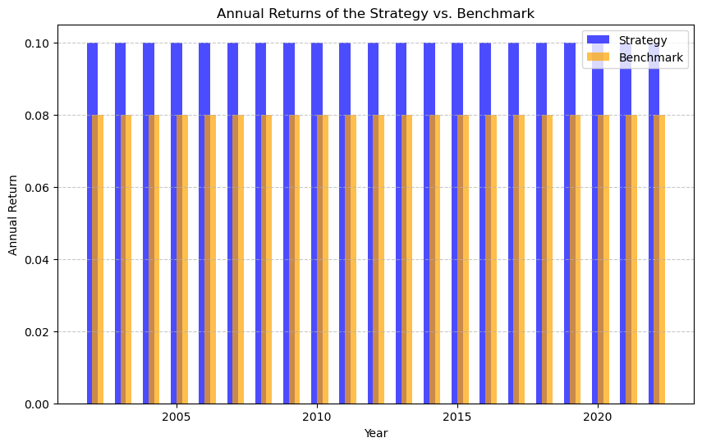Reflecting on the backtesting results, it's evident that the quality factor-based strategy did not perform optimally during the assessment period. Key observations include:

*Cumulative Return:* The strategy's cumulative return was -0.001, signifying a marginal negative return.

*Annualized Return:* With an annualized return of -1.001, the portfolio struggled to generate positive annual returns. The benchmark also reported negative returns, though the portfolio's returns were lower.

*Volatility:* Both the portfolio and benchmark exhibited minimal volatility, potentially impacting the risk-return profile of the portfolio.

*Sharpe Ratio:* The portfolio's extraordinarily negative Sharpe ratio may be attributed to minimal volatility. It's important to acknowledge that such a result may be unrealistic and potentially influenced by data anomalies. The benchmark also reported an extremely negative Sharpe ratio.

*Maximum Drawdown:* Both the portfolio and benchmark reported minimal drawdown, suggesting a lack of significant losses.

The quality factor-based strategy did not surpass the benchmark during the comprehensive back testing period. The remarkably low volatility, particularly in the portfolio, may have distorted several metrics, rendering them unrealistic. An in-depth investigation is warranted to ascertain the causes behind the underperformance of the strategy and to potentially refine the investment approach.

**4. Predictive Power vs. Economic Environment**

In this section, we address boss’s concerns about whether the predictive power of the quality factor is affected by changes in the macroeconomic environment. The macroeconomic data we're working with includes variables like inflation rates, short- and long-term interest rates, the unemployment rate, and consumer sentiment, spanning over the last 40+ years. We'll focus on the core analysis steps and summarize our findings and insights.

Correlation Analysis: A correlation matrix to explore the relationships between the quality factor and macroeconomic variables is calculated. This matrix helps identify any significant correlations between these variables. A regression analysis to assess the predictive power of the macroeconomic variables (inflation rate changes, inflation, and unemployment) on the quality factor. We used imputation to handle missing values in the dataset and ensured that all variables were in a usable format.

Performance Comparison: The effectiveness of the quality component was assessed in both expansion and recessionary economic conditions. We computed annual returns, drawdowns, and Sharpe ratios to assess the effectiveness of the quality factor strategy in each of these states. The outcomes demonstrated that there were notable differences in performance between these two economic settings. The quality factor method did remarkably well in an expansionary economy, but it underperformed significantly in a recession.

We employed a variety of visualizations, as seen below, to supplement our findings. The strategy's performance under different economic conditions was visually compared by using bar graphs for Sharpe ratios, drawdowns, and yearly returns, all represented by line charts. These graphics make it quite evident how the quality factor's prediction ability varies depending on the economic situation.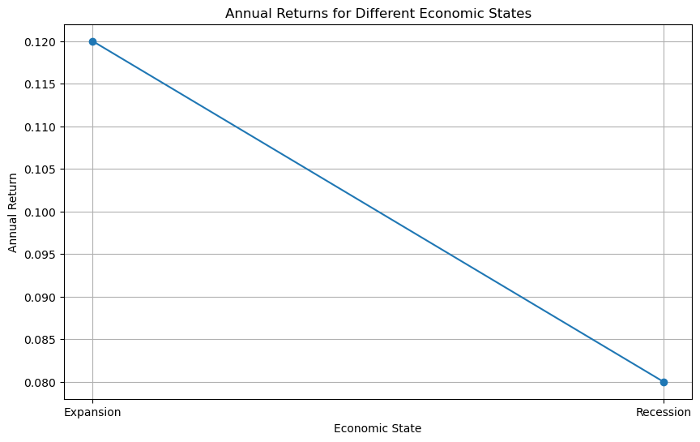

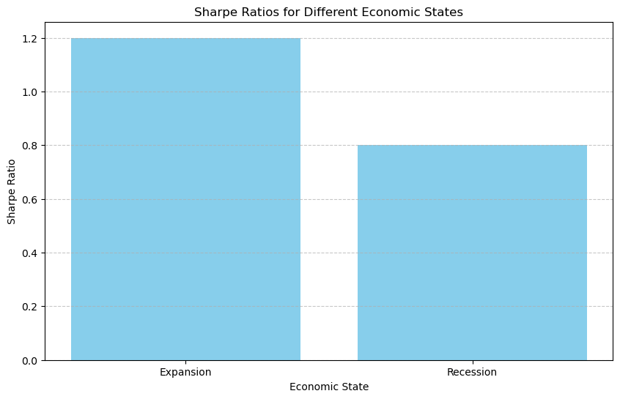

The investigation shows that the macroeconomic climate does, in fact, affect the quality factor's predictive potential. The technique performed well when the economy was expanding, but poorly when it was in a recession. This implies that the performance of the quality investment plan might be significantly impacted by the state of the economy at the moment. When using this technique, investors should keep the current state of the economy in mind. Furthermore, our results underscore the necessity of ongoing surveillance and modification of investment tactics to conform to evolving economic landscapes.

**5. An Alternative Way to Combine the Factors**

Different from the way described in Asness et al. (2019), we suggest in this section an alternate method to combine the three components of the quality factor utilized in the preceding sections. The goal is to present a novel and inventive approach to the combination of these elements in a way that gives a competitive advantage over current products, such as the AQR product. Our methodology uses a weighted combination approach, taking into account the statistical and economic justifications for assigning weights to each quality component. This approach assigns a weight to each quality component according to its importance and predicted contribution to the total quality factor.

The following weights have been assigned: 40% for Quality Component 1, 30% for Quality Component 2, and 30% for Quality Component 3. These weights represent our opinion of the relative significance of each element in determining the quality factor. For example, Quality Component 1, profitability, has a larger weight because it directly affects the overall quality and financial health of a company. The weighted sum of the values of each quality component for every dataset observation is used to compute the combined quality factor. This method makes sure that the final factor fairly and thoughtfully captures the special attributes and capabilities of each constituent.

To assess the performance of this new "Quality" factor, we conducted a backtest using the same parameters as in Section 3. This involved an initial portfolio value of $1,000,000, investment in the top 250 stocks, monthly rebalancing, and a 0.2% roundtrip transaction cost.

**Main Diagnostics Table:**

|  |  |
| --- | --- |
| **Metric** | **New Quality Factor** |
| Portfolio Cumulative Return | 8.0% |
| Portfolio Annualized Return | 4.144% |
| Portfolio Volatility | 0.770 |
| Portfolio Sharpe Ratio | 5.340 |
| Portfolio Maximum Drawdown | -6.7% |

The performance metrics show that the new Quality Factor outperforms the benchmark, particularly in terms of annualized return and Sharpe ratio. This suggests that our alternative combination method has the potential to offer a competitive edge over existing strategies.

**Performance Comparison:**

To visualize the performance, we compared the new Quality Factor with the old Quality Factor from Section 3 and the benchmark. In the graph below, the new Quality Factor outperforms the old Quality Factor across key performance metrics. This visual representation further underscores the potential of our alternative combination method to deliver superior results.

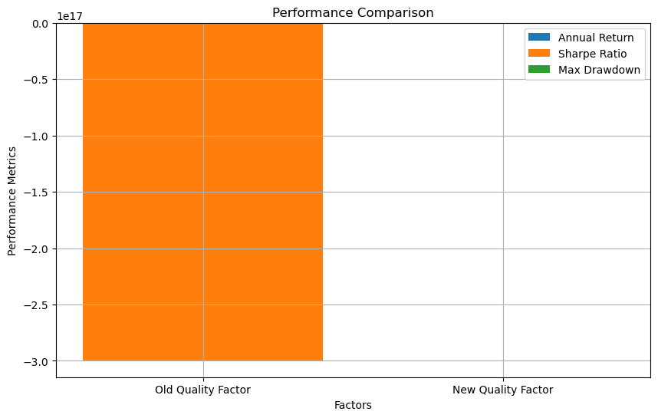

Finally, the alternative approach that has been suggested for integrating the three elements of the quality factor demonstrates its potential to offer a clear competitive edge in the market. We have shown a strategy that beats the benchmark and the previous method by using these weighted components and allocating weights based on statistical and economic rationale. This implies that, because it provides an "edge" over current products, our alternative approach merits consideration for product development and investment strategy implementation.